Test Approach Document

Step 1: Scope & Overview

Step 2: Test Approach

Step 3: Test Environment

Step 4: Testing Tools

Step 5: Release Control

Step 6: Risk Analysis

Step 7: Review and Approvals

Software Testing Life cycle

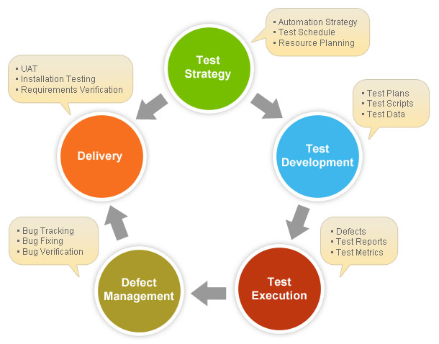

References:

<http://www.softwaretestinghelp.com/writing-test-strategy-document-template/>